NETFLIX CONTENT ANALYTICS

Case Study Report
for the course
Big Data Analytics - 20CS41001

BACHELOR OF TECHNOLOGY IN
COMPUTER SCIENCE AND ENGINEERING

By
Aryan Manish Meshram – 23R11A0504
Varnit Kolakotla – 23R11A0525
Borigam Manikanta – 24R15A0505

Under the guidance of
P Usha Shree



Department of Computer Science and Engineering
Accredited by NBA

Geethanjali College of Engineering and Technology
(UGC Autonomous)
(Affiliated to J.N.T.U.H, Approved by AICTE, New Delhi) Cheeryal (V), Keesara (M), Medchal.Dist.-501 301.

A.Y 2026-27 (Sem-I)

TABLE OF CONTENTS

S.No. | Contents | Page No
1 | Introduction | 1
2 | Dataset Description | 2
3 | Methodologies/Approach | 3
4 | Dashboard Design | 6
5 | Analysis and Insights | 16
6 | Conclusion | 18

Introduction

Streaming platforms have changed how audiences discover and consume entertainment. Netflix offers a broad catalogue of films and television programmes spanning different countries, genres, release periods, and audience ratings. Examining this catalogue through data analytics can help describe the platform’s content mix and identify patterns in the records, such as the balance between movies and TV shows, the most frequently listed genres, the countries most represented, and the years in which titles were released.
The main aim of this project, “Netflix Content Analytics Dashboard,” is to explore the Netflix titles dataset and present its information in a clear, interactive visual form. The dataset includes title identifiers, content type, title, director, cast, country, date added, release year, rating, duration, listed genres, and a short description. These fields support comparisons across content types, production regions, genre labels, age classifications, and time.
The project uses Tableau as the primary data visualization tool. The dashboard is intended to convert the source table into a collection of charts and summary views that users can explore without manually scanning thousands of rows. The analysis focuses on catalogue composition and recorded metadata; it does not measure viewership, popularity, subscriber behaviour, or business performance because those measures are not included in the supplied file.
The project objectives are to:
- Summarize the total number of titles and compare movies with TV shows.
- Explore the distribution of titles by country and genre.
- Examine release-year patterns and the years in which titles were added to Netflix.
- Compare content ratings and duration characteristics.
- Use interactive filters and tooltips to support focused exploration of the catalogue.
By presenting these patterns visually, the dashboard aims to make the dataset easier to understand and demonstrate how data visualization supports exploratory analysis.

Dataset Description

Dataset Name and Size
The project uses the supplied Netflix titles CSV file. It contains 8,807 records and 12 columns. Each row represents a listed title, with fields describing its type and available catalogue metadata. The dataset is a snapshot of titles and dates recorded in the file; it should not be treated as a live or complete view of Netflix’s current catalogue.

Attributes and their meaning
The dataset includes several important attributes used for analysis:
Attribute | Meaning / Use
show_id | Unique identifier assigned to a title in the file.
type | Indicates whether the title is a Movie or TV Show.
title | Name of the movie or programme.
director | Director information, where available.
cast | Listed cast members, where available.
country | Country or countries associated with the title.
date_added | Date the title was added to Netflix, where recorded.
release_year | Year the title was released.
rating | Content rating classification.
duration | Movie runtime in minutes or TV show length in seasons.
listed_in | Genre/category labels associated with the title.
description | Short text description of the title.

Table 2.1: Attributes and Meaning

Initial Dataset Summary

Measure | Observed value
Total records | 8,807
Movies | 6,131 (69.6%)
TV Shows | 2,676 (30.4%)
Distinct release years | 74
Date-added range | January 01, 2008 to September 25, 2021

Table 2.1: Attributes and Meaning

Methodology / Approach
The workflow for this project begins with importing the CSV dataset, checking the available fields, preparing the data for analysis, creating calculated measures where required, and building visualizations in Tableau. The aim is to make the source information consistent and to ensure that the charts answer specific questions about the catalogue.

Data Importing

The Netflix dataset was supplied as a comma-separated values (CSV) file and can be connected directly to Tableau. After importing, the field names and data types should be checked. Release year is numeric, while fields such as type, country, rating, and listed_in are categorical. The date_added field should be interpreted as a date, and duration should be treated carefully because it contains values expressed in minutes for movies and seasons for TV shows.

Data Preparation

The source file contains some missing values in metadata fields. Missingness is not uniform across the dataset, so each chart should use the fields relevant to that analysis and should not imply that an unavailable value is zero.
- Missing director values: 2,634.
- Missing cast values: 825.
- Missing country values: 831.
- Missing date_added values: 10.
- Missing rating values: 4; missing duration values: 3.
- Date parsing: convert date_added to a date field and derive the addition year only for records with a valid date.
- Categorical fields: trim and split comma-separated country and genre labels when the analysis intends to count each listed category separately.
The source values should be retained where possible. Nulls can be excluded from a chart that requires the relevant field, while a separate data-quality note can communicate the amount of missing information.

Calculated Fields

The following calculated fields can support the Tableau workbook. Their exact names may be adjusted to match the workbook.
Calculated field | Example logic | Purpose
Title Count | COUNTD([show_id]) | Counts unique title records.
Addition Year | YEAR([date_added]) | Supports analysis of catalogue additions by year.
Content Type Share | COUNTD([show_id]) / TOTAL(COUNTD([show_id])) | Shows the percentage share of each content type.
Duration Value | Extract numeric part of [duration] | Allows duration summaries only when Movie and TV Show units are analysed separately.

Table 3.1 Calculated Fields
  - Chart Selection Rationale

- KPI cards: summarize total titles, movies, and TV shows.
- Content Type Distribution: compares the number of movies and TV shows.
- Titles by Release Year: shows how the catalogue’s release-year distribution changes over time.
- Titles Added by Year: summarizes the dates on which titles were added, using valid date_added records.
- Top Countries: ranks countries represented in the dataset; multi-country titles need a consistent counting rule.
- Genre Distribution: compares listed genre labels, noting that a title may have multiple labels.
- Content Ratings: shows the frequency of rating categories.
- Duration Analysis: compares movie runtime in minutes and TV show length in seasons without mixing the units.

  - Dashboard Design Process

A. Layout Design
The dashboard should use a clear hierarchy so that viewers can move from a high-level summary to more detailed comparisons.
- Top section: KPI cards for the total number of titles, movies, and TV shows.
- Main section: content-type comparison and time-based charts.
- Category section: country, genre, and rating comparisons.

B. Interactivity
- Filters: allow users to narrow the view by content type, release year, country, rating, or genre where the field is available.
- Tooltips: reveal title counts and category labels without overcrowding the charts.
- Dashboard actions: where configured, selecting a category in one chart can filter or highlight related views.
- Sorting: rank categorical bars in descending order to make comparisons easier.

C. Visual Design
Use consistent typography, legible axis labels, descriptive chart titles, and restrained colour. A distinct colour for Movie and TV Show can improve the content-type comparison, while categorical charts should use colours consistently rather than assigning arbitrary meaning to every bar. Long country and genre labels may require horizontal bars or carefully controlled scrolling.
The dashboard should distinguish counts of titles from counts of category labels. A title can be associated with multiple countries or genres, so category totals may exceed the total number of unique titles when each label is counted separately.

Dashboard Design

The Netflix Content Analytics Dashboard is designed to summarize the supplied catalogue in a single interactive view. It combines key performance indicators with categorical and temporal charts so that users can compare the composition of titles and investigate patterns in the available metadata.

4.1. Main Dashboard Layout and Interactivity

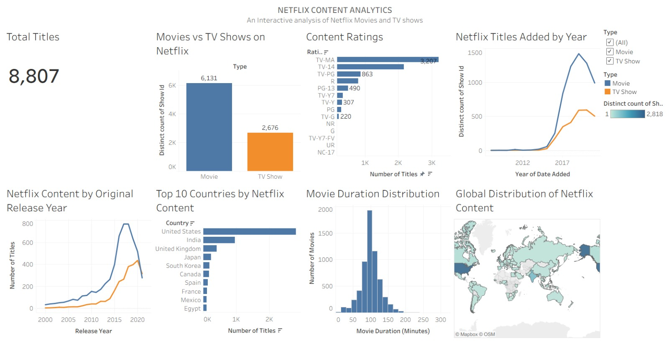

Figure 4.1: Netflix Content Analytics Dashboard

The dashboard can be organized into four functional areas:
- Header and KPIs: total titles, movie count, and TV show count.
- Content overview: a direct comparison of movies and TV shows.
- Analytical charts: release-year trends, date-added trends, country representation, genre distribution, rating distribution, and duration characteristics.
- Exploration controls: filters and tooltips that allow users to focus on selected categories.

Dashboard Interactivity
Filters should be selected according to the questions the dashboard is intended to answer. For example, a user can focus on TV Shows to compare ratings or seasons, or focus on a selected country to inspect its representation in the catalogue. Tooltips should expose useful context such as category name, number of titles, and the relevant date or rating field.
The dataset does not include streaming counts, ratings from viewers, revenue, or user engagement. Therefore, the dashboard should describe the titles represented in the CSV rather than making claims about what audiences watched most or which titles performed best.

4.1.1 KPI Cards and Content Type Distribution

KPI Cards
The KPI cards provide a quick summary of the dataset before users explore individual charts. The source file contains 8,807 records, including 6,131 movies and 2,676 TV shows. Movies represent approximately 69.6% of the rows and TV shows approximately 30.4%. These figures describe the composition of this file, not necessarily the current Netflix catalogue.
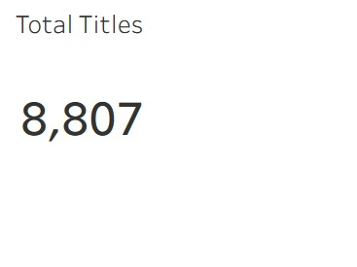  Figure 4.1.1.1: Total Titles | 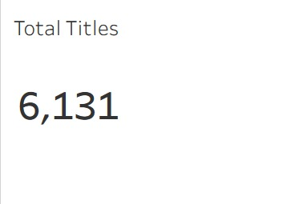  Figure 4.1.1.2: Total Movie Titles | 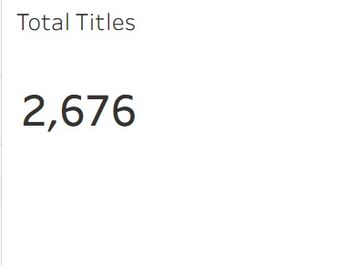  Figure 4.1.1.3: Total TV Show Titles

Content Type Distribution
What it shows: a bar chart or donut chart compares Movie and TV Show records.
Why chosen: this comparison establishes the overall balance of content types and provides a useful starting point for the rest of the dashboard.
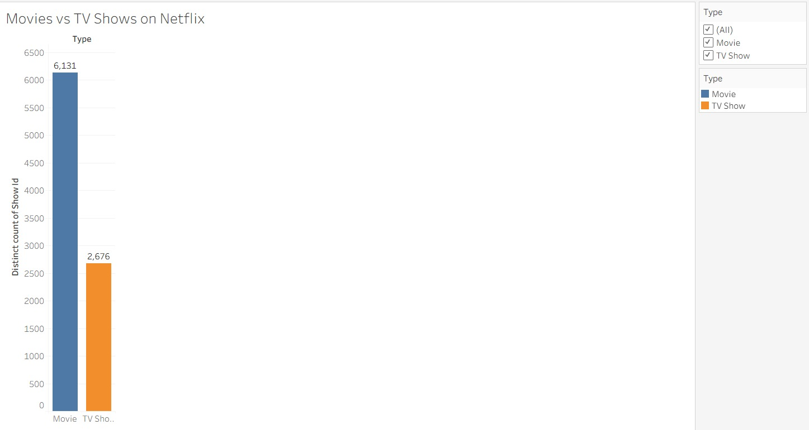
Figure 4.1.1.4: Movie and TV Show Distribution

Content type | Number of records | Share
Movie | 6,131 | 69.6%
TV Show | 2,676 | 30.4%
Total | 8,807 | 100.0%
Figure 4.1.1: Content Distribution Types
Interpretation: movies form the larger share of the dataset. The difference is descriptive and should not be interpreted as a measure of quality, popularity, or viewing demand.

4.2. Temporal Analysis

Titles by Release Year
What it shows: a line chart or column chart counts titles by release_year.
Why chosen: the view helps identify release periods that are more strongly represented in the dataset. It is important to distinguish the year a title was released from the year it was added to Netflix.
Release year | Title records
2018 | 1,147
2017 | 1,032
2019 | 1,030
2020 | 953
2016 | 902
2021 | 592
Figure 4.2: Temporal Analysis
The most represented release year in the file is 2018, with 1,147 records. The number of titles released in a year does not necessarily reflect the year they became available on Netflix.
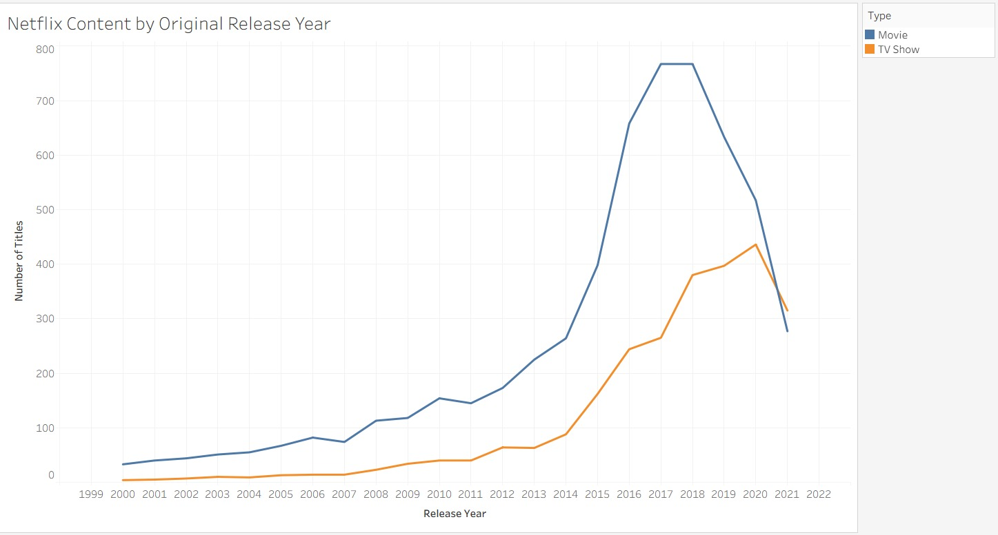
Figure 4.2.1: Netflix Content by Original Release Year

Titles Added by Year
What it shows: a column chart groups valid date_added values by calendar year.
Why chosen: it describes the timing of additions represented in the source data. The file has 10 records without date_added, so these records cannot be assigned to an addition year without additional information.
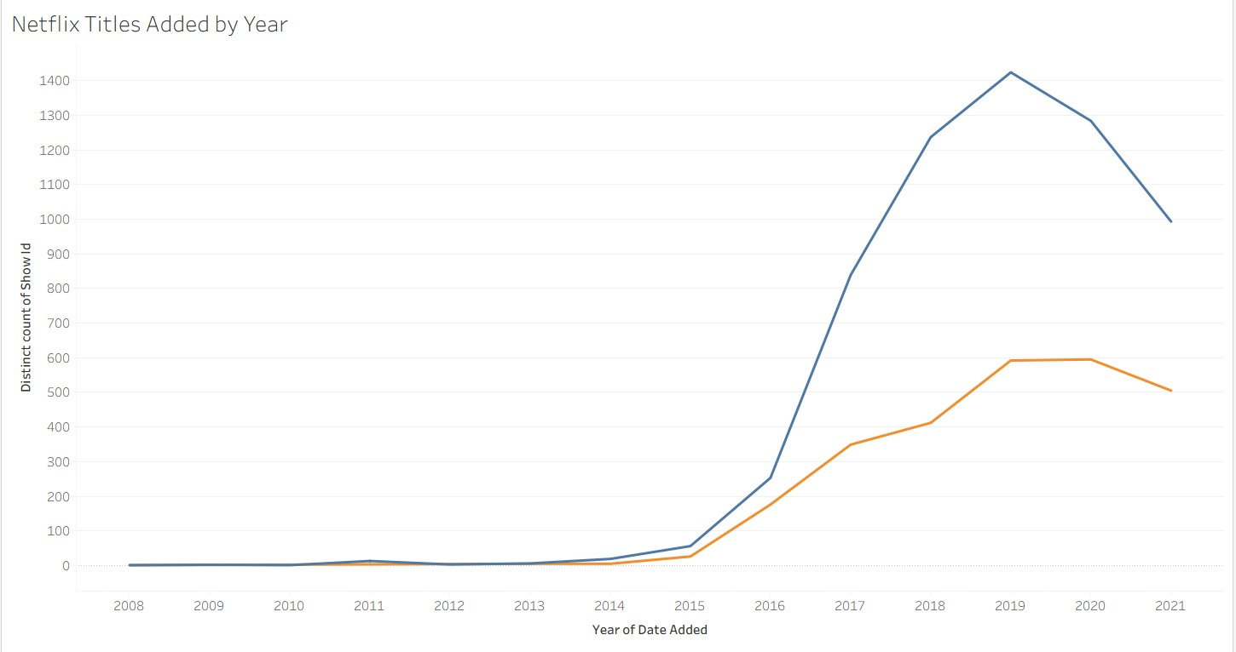
Figure 4.2.2: Netflix Titles Added by Year

4.3. Country Representation

Top Countries by Title Records
What it shows: a horizontal bar chart ranks countries by the number of title records associated with each country.
Why chosen: country comparisons provide a view of the geographic representation of the catalogue.
Country label | Associated title records
United States | 3,689
India | 1,046
United Kingdom | 804
Canada | 445
France | 393
Japan | 318
Spain | 232
South Korea | 231
Figure 4.3: Top 10 Countries by Title Records
The United States is the most frequently listed country label in this dataset, followed by India and the United Kingdom. Because the country field can contain more than one country for a title, the table above counts each comma-separated country label separately. Consequently, the sum of country counts can exceed the total number of title records.
This chart indicates how titles are represented in the file’s country metadata. It should not be used to infer where a title was watched or the size of a country’s audience.
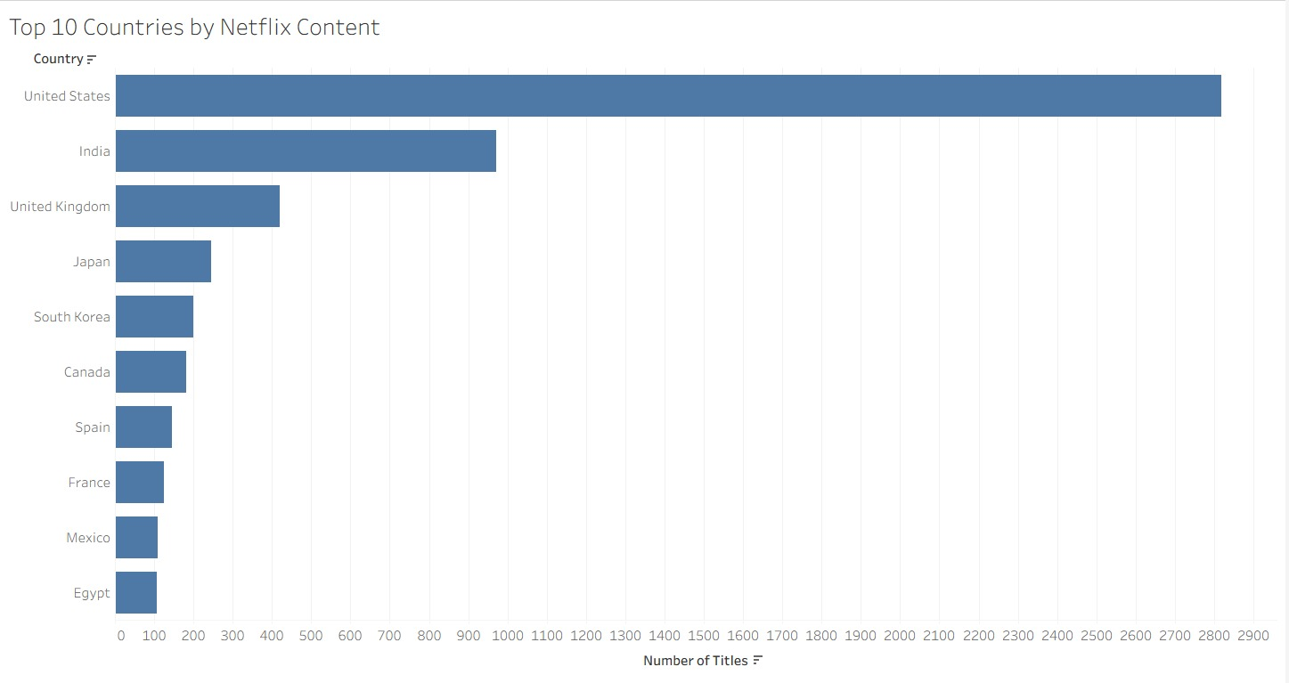
Figure 4.3: Top 10 Countries by Netflix Content

4.4. Genre Distribution

Most Frequently Listed Genres
What it shows: a horizontal bar chart compares the most common labels in the listed_in field.
Why chosen: genre labels help summarize the variety of content categories present in the dataset. A title may have multiple genre labels, so the view counts label occurrences rather than assigning each title to only one genre.
Genre label | Label occurrences
International Movies | 2,752
Dramas | 2,427
Comedies | 1,674
International TV Shows | 1,351
Documentaries | 869
Action & Adventure | 859
TV Dramas | 763
Independent Movies | 756
Figure 4.4: Most Frequently Listed Genres
International Movies, Dramas, and Comedies are the three most frequently occurring labels in the supplied file. These are metadata categories; they do not necessarily represent mutually exclusive groups.

Reading the Chart
Use a descending sort to make the most common categories easy to identify. If the full list is too long, display a Top N selection and provide a filter for additional categories. Tooltips can clarify the count and exact genre label.

4.5. Content Rating Distribution

Content Ratings
What it shows: a bar chart displays the number of records associated with each content rating.
Why chosen: ratings offer a view of how the catalogue is classified for different audiences. The meaning of ratings can vary by rating system and region, so categories should be presented as recorded rather than treated as a universal age scale.
Rating | Title records
TV-MA | 3,207
TV-14 | 2,160
TV-PG | 863
R | 799
PG-13 | 490
TV-Y7 | 334
TV-Y | 307
PG | 287
Figure 4.5: Content Ratings
TV-MA is the most frequently recorded rating in the file (3,207 records), followed by TV-14 (2,160). Four records have no rating value. The chart should retain a clear distinction between a missing rating and a rating category such as NR or Unrated.

Analytical Use
Rating distribution can be compared after filtering by type, country, or release period. Such comparisons describe the metadata in the file and should not be interpreted as evidence about audience suitability beyond the classification labels supplied.
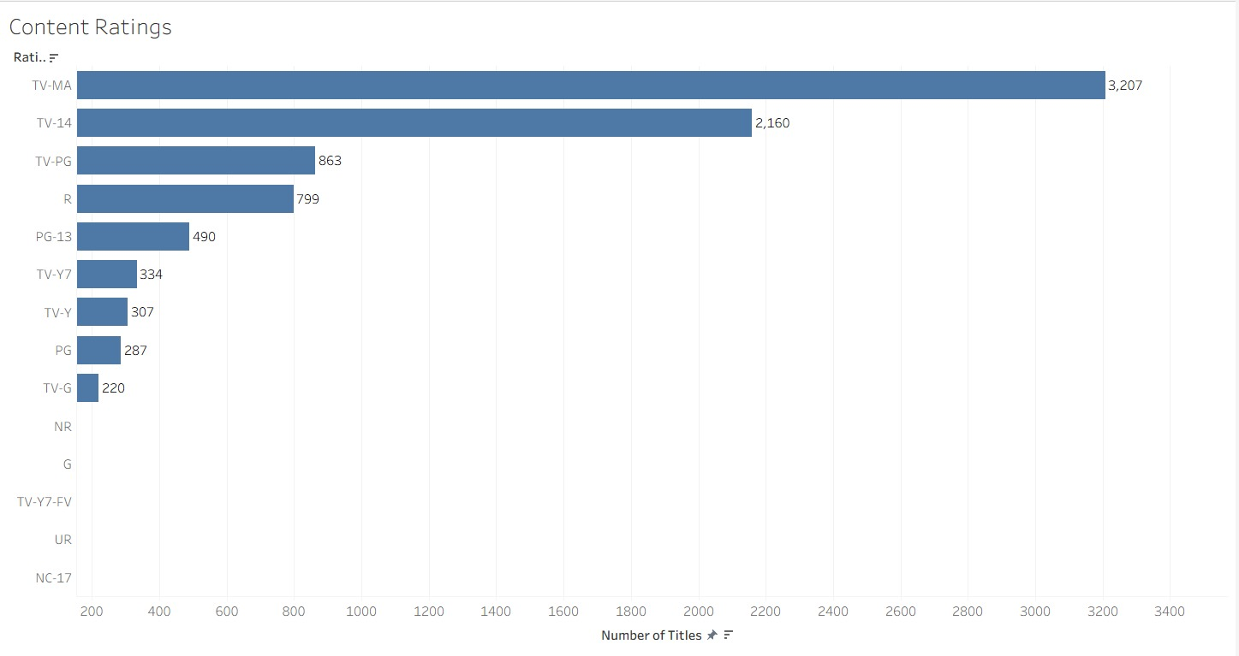
Figure 4.5: Distribution of Netflix Content Ratings

4.6. Duration Analysis

Movie Runtime and TV Show Seasons
What it shows: duration is summarized separately for movies and TV shows. Movie values are generally expressed in minutes, while TV Show values are expressed in seasons.
Why chosen: duration is useful for describing format differences, but the two units are not directly comparable. A single combined numeric axis would be misleading unless the units are clearly separated.
Type | Records with duration | Median | Observed range
Movie | 6,128 | 98 minutes | 3–312 minutes
TV Show | 2,676 | 1 seasons | 1–17 seasons
Figure 4.6: Movie Runtime and TV Shows Seasons
The numeric component is extracted only to support a summary within each type. The report does not treat movie minutes and TV seasons as equivalent measures. Three records have no duration value in the source file.

Suggested Presentation
A separate box plot or histogram for each content type can reveal typical values and variation. If a simpler dashboard is preferred, use separate KPI summaries for median movie runtime and median TV show seasons.
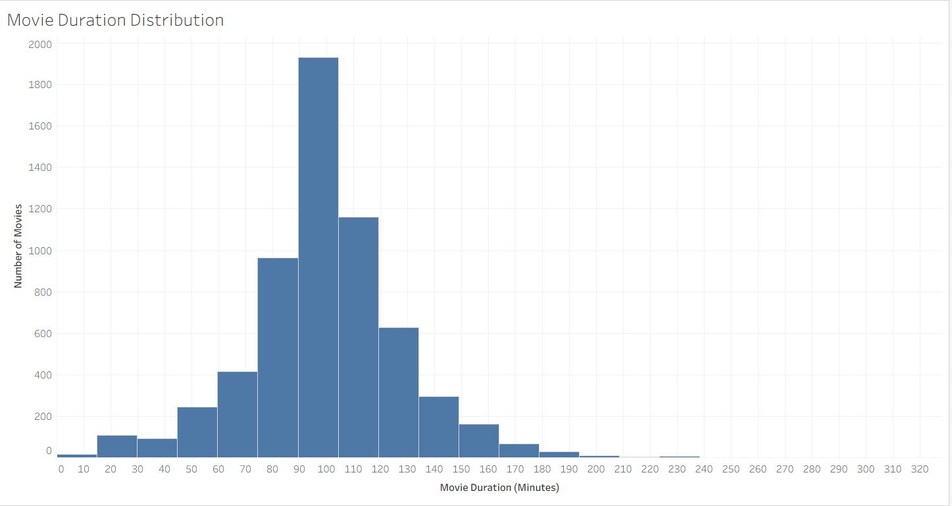
Figure 4.6: Movie Duration Distribution

4.7. Global Distribution of Netflix Content
The map shows the countries represented in the Netflix dataset and provides a geographic overview of the catalogue. Country values can include multiple countries for one title, so the map should be interpreted as a view of country representation rather than audience location.
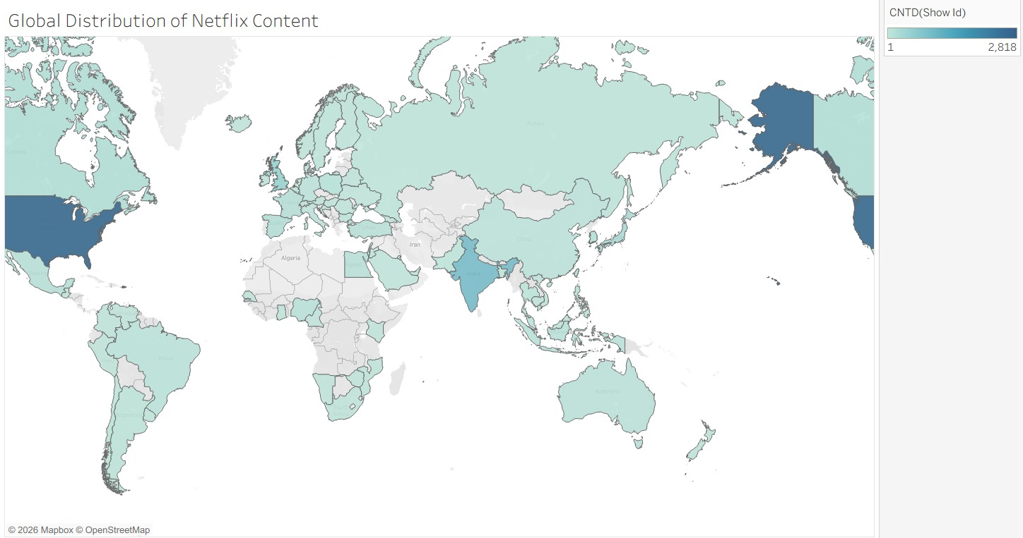
Figure 4.7: Global Distribution of Netflix Content

Analysis and Insights

The dataset provides several descriptive insights into the titles and metadata included in the supplied Netflix CSV. The findings below are based on counts in the file and should be interpreted as catalogue metadata patterns, not as measures of viewing behaviour.

Insight 1: Movies Make Up the Larger Share

- Key finding: 6,131 records are Movies and 2,676 are TV Shows.
- Supporting data: Movies account for 69.6% of all records, compared with 30.4% for TV Shows.
- Observation: the file contains more than twice as many movie records as TV show records. This makes content type a useful filter for more detailed comparisons. See Figures 2–5 in Section 4 for the KPI cards and content-type comparison.

Insight 2: The Catalogue Has Strong Representation of Recent Releases
- Key finding: 2018 is the most represented release year, with 1,147 title records.
- Supporting data: the highest-count release years are concentrated in the late 2010s and early 2020s.
- Observation: this is a pattern in the release years recorded in the file; it should not be confused with when titles were added to the platform. See Figures 6–7 in Section 4 for the release-year and date-added trends.

Insight 3: Country Labels Are Concentrated in a Few Countries
- Key finding: United States is the most frequently listed country label (3,689), followed by India (1,046).
- Observation: country metadata may include multiple countries per title, so the counts represent country-label associations rather than exclusive country ownership. See Figures 8 and 11 in Section 4 for the country ranking and global map.

Insight 4: Genre Labels Overlap
- Key finding: International Movies, Dramas, and Comedies are the three most frequently listed genre labels.
- Observation: because titles can carry several labels, genre counts should not be expected to add up to the total number of titles.

Insight 5: TV-MA Is the Most Common Rating Label
- Key finding: TV-MA appears on 3,207 records and TV-14 on 2,160.
- Observation: rating categories can be explored by content type or country, but the dataset alone does not establish the reasons behind the distribution. See Figure 9 in Section 4 for the content-rating distribution.

Insight 6: Metadata Completeness Varies
- Key finding: the file has 2,634 missing director values, 825 missing cast values, and 831 missing country values.
- Observation: charts should handle missing values transparently and use the records with relevant non-null fields. Missing values should not be silently converted into zero.

Limitations

The file does not contain view counts, audience ratings, revenue, subscription data, or recommendation outcomes. It is therefore unsuitable for claims about popularity or commercial success. Some records have incomplete metadata, and the date_added field contains missing values. Category counts for country and genre may overlap because titles can have multiple labels.

Conclusion

This project uses the Netflix titles dataset to demonstrate how data visualization can make a large catalogue easier to explore. The source file contains 8,807 records and 12 fields covering content type, title details, country, release year, date added, rating, duration, genre labels, and descriptions. Tableau can bring these fields together in a dashboard with summary cards and analytical charts.
The analysis shows that movies form the larger share of the file (6,131 records, 69.6%), while TV shows account for 2,676 records (30.4%). The United States is the most frequently listed country label, and International Movies, Dramas, and Comedies are the most common genre labels. TV-MA is the most common rating category. The release-year distribution is most concentrated around 2018. These findings describe the supplied records and do not indicate viewing popularity or audience preferences.
The dashboard’s main benefit is that it supports comparisons across multiple dimensions without requiring users to inspect the raw CSV manually. Filters, tooltips, consistent labels, and sorted charts can make it easier to focus on specific content types or categories. Careful treatment of multi-valued country and genre fields is important because their category counts can overlap.
The project can be improved by aligning the final report with the exact worksheets in the completed Tableau workbook, adding screenshots of the final dashboard, and documenting any filters or calculated fields actually implemented. Further analysis would require additional reliable data such as viewing hours or audience engagement measures. Overall, the project illustrates how a structured dataset and a well-designed dashboard can support clear exploratory analysis while making the limits of the available data explicit.

